**Complex Systems HW2.b**

P. Alexander Burnham

February 27, 2018

**c)** See Attached Code

**d)** See Attached Code

**e)** See Attached Code

**f)** See Attached Code

**g)** See Attached Code

**h)** *Did not complete*

**i)** In general, Forward Euler seemed to react to these sets more of initial conditions more drastically than ode45 and Heun. Both ode45 and Heun exhibited fixed point attraction at the low a value, when into a periodic orbit at the medium a value and entered chaotic regimes when a was high. Truncation error due to the order of accuracy larger plays into this. Euler is only first order accurate, making it more susceptible to truncation error than Heun (2nd order) and ode45 (4th order) and is, in general more susceptible to step size. Though Heun closely follows ode45, it also drifts away at higher time steps at high “a” and “h” values as truncation error and susceptibility to step size become into play.

When a = 0.75 and h=0.1, all three methods behaved very similarly (**Fig. 1**). However, increasing the step size h for each value of a seemed to drive Forward Euler further from the other methods. Oscillations that damp down in ode45 and Heun become exacerbated or fail to dampen in Forward Euler (**Fig. 2 & 3**). In general, based on the plots of all three species and species through time figures, Forward Euler seems more easily driven into a chaotic regime (**Figs. 2, 3, 5, 6 & 9**). Indeed, Forward Euler which the highest “a” of 1.5 and largest of “h” of 1 became numerically unstable and “blew up” (**Fig. 9**). The combination of high a (chaotic regime) and large step size, lead to numeric instability in this method and as a results, drifted wildly away from where it should be.

**Figure 1: a = 0.75, h = 0.1**

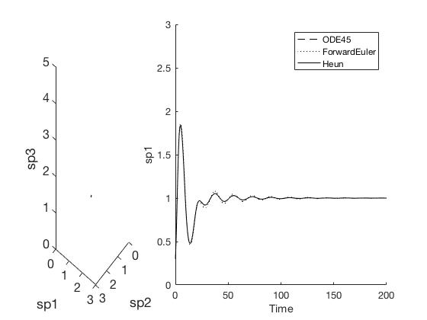

**Figure 2: a = 0.75, h = 0.5**

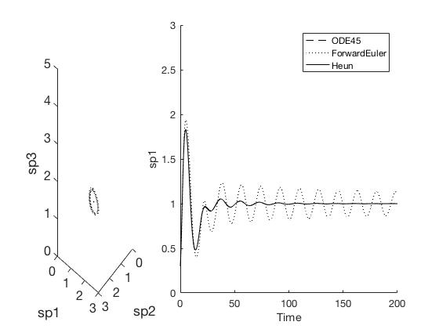

**Figure 3: a = 0.75, h = 1**

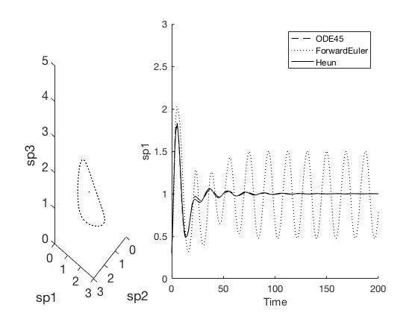

**Figure 4: a = 1.2, h = 0.1**

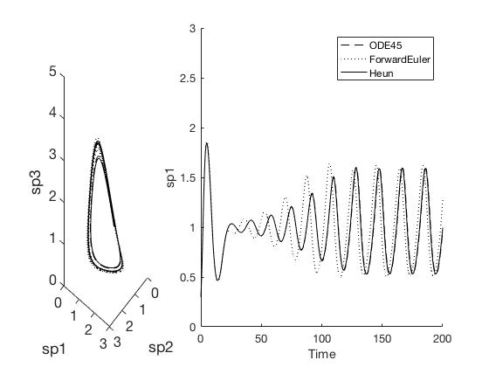

**Figure 5: a = 1.2, h = 0.5**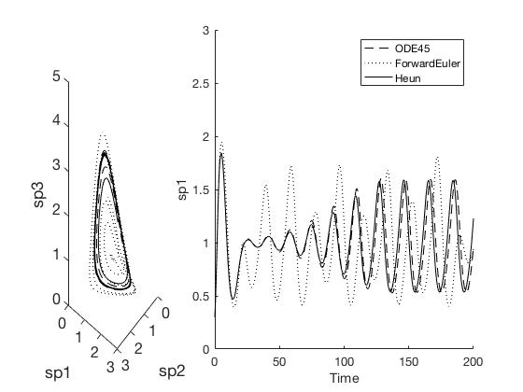

**Figure 6: a = 1.2, h = 1**

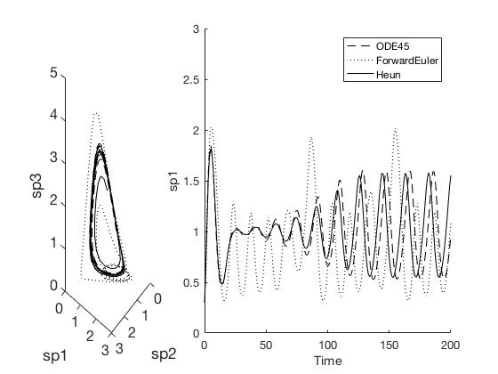

**Figure 7: a = 1.5, h = 0.1**

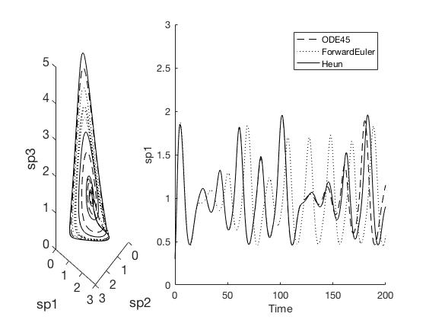

**Figure 8: a = 1.5, h = 0.5**

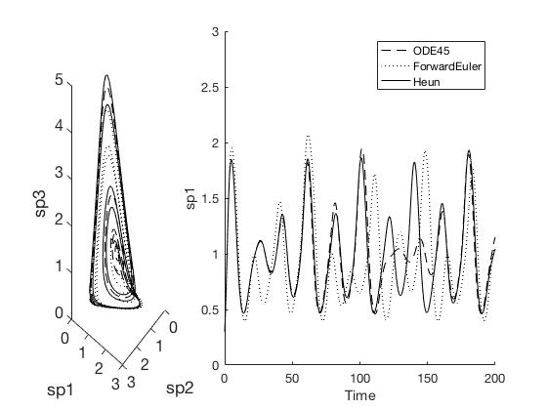

**Figure 9: a = 1.5, h = 1**

